Due 10/6

**Write a 3-page paper on the following topics:
- Curt Flood's Impact on Collective Bargaining
*******Read Chapter 5.1 & 5.5 Case Studies and answer questions: (SEE BELOW)

5.1 (Questions 1- 4)
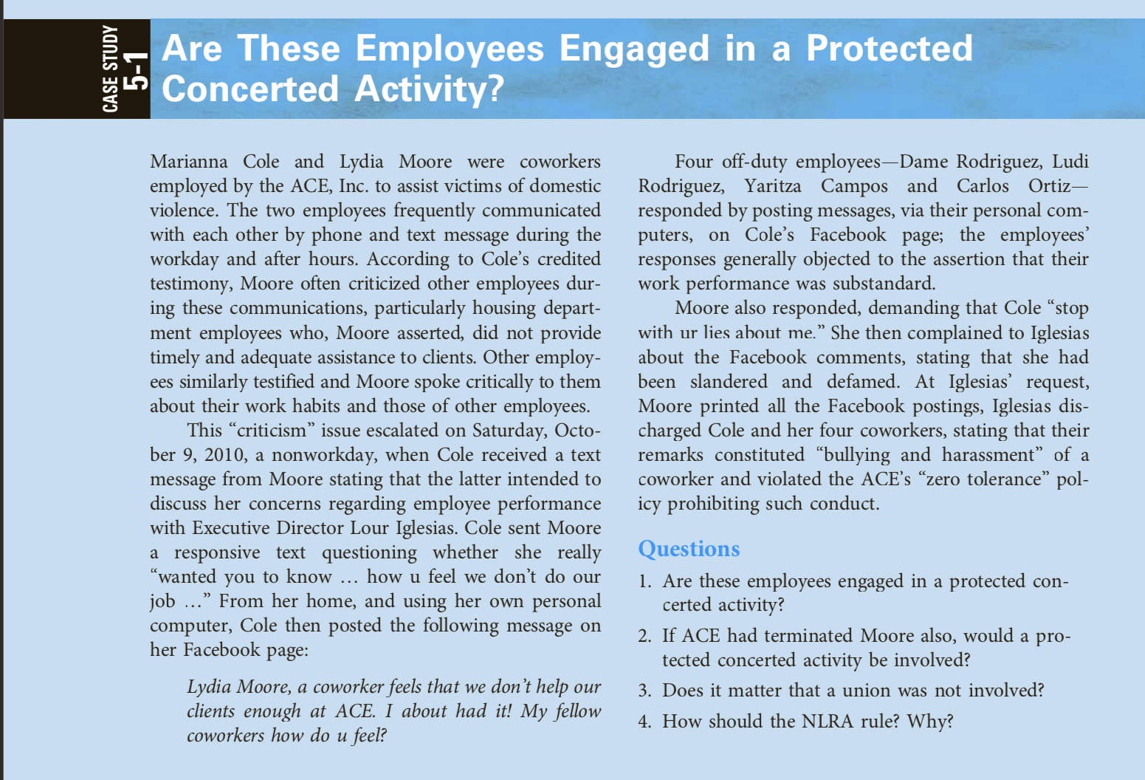

5.5 Questions (1 - 3)
